eds

**Industrial Internship Report on**

**” Human Resource Management System”**

**Prepared by**

**Rishav Sajjan Pandey**

|  |
| --- |
| *Executive Summary* |
| This report provides details of the Industrial Internship provided by upskill Campus and The IoT Academy in collaboration with Industrial Partner UniConverge Technologies Pvt Ltd (UCT).  This internship was focused on a project/problem statement provided by UCT. We had to finish the project including the report in 6 weeks’ time.  My project was The Human Resource Management System (HRMS) is a software application designed to streamline and automate various HR processes within an organization. It serves as a centralized platform that helps HR professionals efficiently manage employee-related tasks, data, and information. The primary objective of an HRMS is to enhance the overall effectiveness of HR operations, improve employee engagement, and ensure compliance with employment laws and regulations  This internship gave me a very good opportunity to get exposure to Industrial problems and design/implement solution for that. It was an overall great experience to have this internship. |

**TABLE OF CONTENTS**

1 Preface 3

2 Introduction 4

2.1 About UniConverge Technologies Pvt Ltd 4

2.2 About upskill Campus 8

2.3 Objective 9

2.4 Reference 9

2.5 Glossary 10

3 Problem Statement 11

4 Existing and Proposed solution 12

5 My learnings 15

6 Future work scope 16

# Preface

Summary of the whole 6 weeks’ work.

About need of relevant Internship in career development.

Brief about Your project/problem statement.

Opportunity given by USC/UCT.

How Program was planned

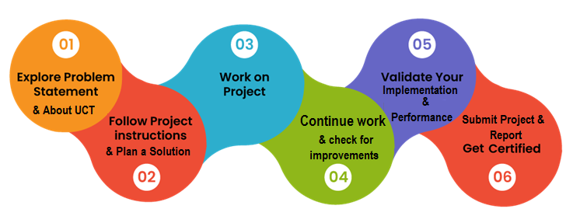

Your Learnings and overall experience.

Thank to all (with names), who have helped you directly or indirectly.

Your message to your juniors and peers.

# Introduction

## About UniConverge Technologies Pvt Ltd

A company established in 2013 and working in Digital Transformation domain and providing Industrial solutions with prime focus on sustainability and RoI.

For developing its products and solutions it is leveraging various**Cutting Edge Technologies e.g. Internet of Things (IoT), Cyber Security, Cloud computing (AWS, Azure), Machine Learning, Communication Technologies (4G/5G/LoRaWAN), Java Full Stack, Python, Front end**etc.

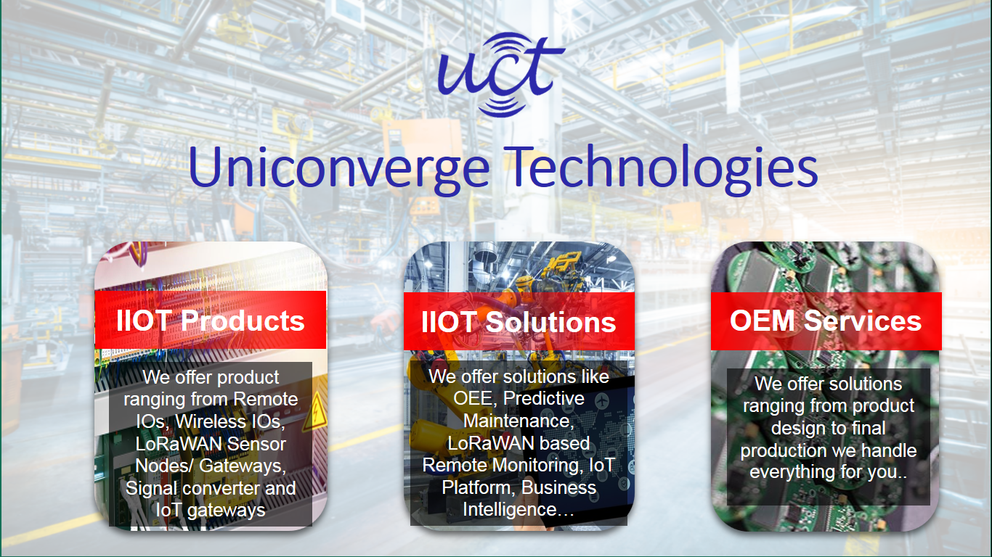

1. UCT IoT Platform **(****)**

**UCT Insight** is an IOT platform designed for quick deployment of IOT applications on the same time providing valuable “insight” for your process/business. It has been built in Java for backend and ReactJS for Front end. It has support for MySQL and various NoSql Databases.

* It enables device connectivity via industry standard IoT protocols - MQTT, CoAP, HTTP, Modbus TCP, OPC UA
* It supports both cloud and on-premises deployments.

It has features to  
• Build Your own dashboard  
• Analytics and Reporting  
• Alert and Notification  
• Integration with third party application(Power BI, SAP, ERP)  
• Rule Engine

 

1. **Smart Factory Platform (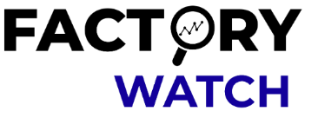)**

Factory watch is a platform for smart factory needs.

It provides Users/ Factory

* with a scalable solution for their Production and asset monitoring
* OEE and predictive maintenance solution scaling up to digital twin for your assets.
* to unleased the true potential of the data that their machines are generating and helps to identify the KPIs and also improve them.
* A modular architecture that allows users to choose the service that they what to start and then can scale to more complex solutions as per their demands.

Its unique SaaS model helps users to save time, cost and money.

 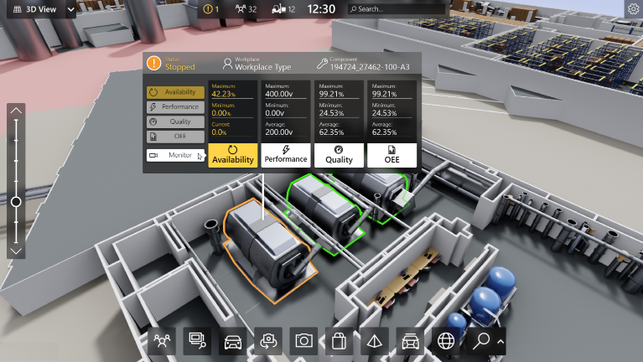

1. 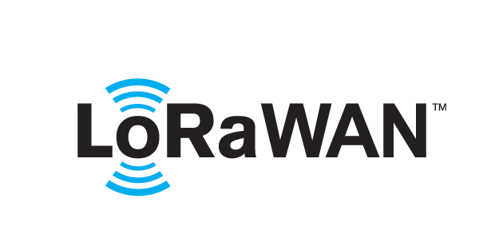 based Solution

UCT is one of the early adopters of LoRAWAN teschnology and providing solution in Agritech, Smart cities, Industrial Monitoring, Smart Street Light, Smart Water/ Gas/ Electricity metering solutions etc.

1. Predictive Maintenance

UCT is providing Industrial Machine health monitoring and Predictive maintenance solution leveraging Embedded system, Industrial IoT and Machine Learning Technologies by finding Remaining useful life time of various Machines used in production process.



## About upskill Campus (USC)

upskill Campus along with The IoT Academy and in association with Uniconverge technologies has facilitated the smooth execution of the complete internship process.

USC is a career development platform that delivers **personalized executive coaching** in a more affordable, scalable and measurable way.

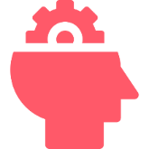

Seeing need of upskilling in self paced manner along-with additional support services e.g. Internship, projects, interaction with Industry experts, Career growth Services

<https://www.upskillcampus.com/>

upSkill Campus aiming to upskill 1 million learners in next 5 year

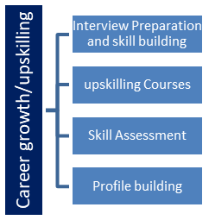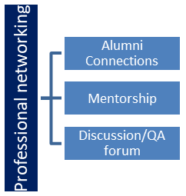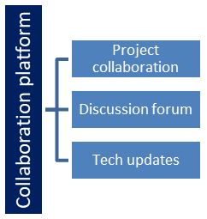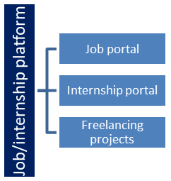

## The IoT Academy

The IoT academy is EdTech Division of UCT that is running long executive certification programs in collaboration with EICT Academy, IITK, IITR and IITG in multiple domains.

## Objectives of this Internship program

The objective for this internship program was to

 ☛ get practical experience of working in the industry.

 ☛ to solve real world problems.

 ☛ to have improved job prospects.

 ☛ to have Improved understanding of our field and its applications.

 ☛ to have Personal growth like better communication and problem solving.

# Problem Statement

**Human Resource Management System (HRMS)**

The Human Resource Management System (HRMS) is a software application designed to streamline and automate various HR processes within an organization. It serves as a centralized platform that helps HR professionals efficiently manage employee-related tasks, data, and information. The primary objective of an HRMS is to enhance the overall effectiveness of HR operations, improve employee engagement, and ensure compliance with employment laws and regulations.

Key features of a Human Resource Management System may include:

1. Employee Information Management: HRMS maintains a comprehensive database of employee details, including personal information, employment history, performance evaluations, skills, and training records.

2. Payroll and Benefits Administration: HRMS facilitates the processing of payroll, tax deductions, and employee benefits, ensuring accurate and timely compensation.

3. Attendance and Leave Management: It tracks employee attendance, time off, and manages leave requests, allowing for efficient scheduling and resource planning.

4. Recruitment and Onboarding: HRMS assists in the recruitment process by posting job openings, managing applications, and organizing candidate interviews. It also helps with the onboarding process for new hires.

5. Performance Management: This module enables the establishment of performance goals, ongoing feedback, and performance reviews for employees.

6. Training and Development: HRMS helps identify training needs, schedule training sessions, and track employees' progress in skill development.

# Existing and Proposed solution

Provide summary of existing solutions provided by others, what are their limitations?

As of my last update in September 2021, Human Resource Management Systems (HRMS) or Human Resource Information Systems (HRIS) are software solutions designed to streamline and automate various HR tasks and processes. These systems are utilized by businesses and organizations to manage employee data, payroll, recruitment, performance evaluations, benefits administration, and other HR-related activities.

1. SAP SuccessFactors:

Summary: SAP SuccessFactors is a cloud-based HRMS solution that offers a comprehensive suite of modules to manage various HR functions. It covers core HR, talent management, learning management, and analytics.

Limitations: It can be expensive, especially for small and medium-sized businesses. The implementation process may be complex and time-consuming, requiring specialized expertise.

2. BambooHR:

Summary: BambooHR targets small to medium-sized businesses, offering user-friendly HR management features such as employee onboarding, time tracking, and applicant tracking.

Limitations: Some users find that advanced HR functionalities are limited, which might not be suitable for large or complex organizations with more extensive HR needs.

3. Oracle HCM Cloud:

Summary: Oracle HCM Cloud is an enterprise-grade HRMS with a wide range of HR and talent management capabilities. It provides extensive analytics and reporting features.

Limitations: Similar to SAP SuccessFactors, implementation and maintenance costs can be high, making it more suitable for larger organizations.

What is your proposed solution?

1. Requirements Gathering: Understand the specific needs and requirements of the organization. This involves collaborating with HR professionals and other stakeholders to identify the key features and functionalities needed in the HRMS.

2. Database Design: Create a well-structured database to store all employee-related data securely and efficiently. This database should include information such as employee profiles, attendance records, performance evaluations, payroll data, and more.

3. Employee Self-Service Portal: Develop a user-friendly web portal that allows employees to access their personal information, view payslips, apply for leave, and update their details, reducing the administrative burden on HR staff.

6. Time and Attendance Tracking: Implement a system to monitor employee attendance, manage leaves, and track work hours accurately for payroll processing.

7. Payroll Management: Develop a robust payroll module that calculates salaries, taxes, and deductions, ensuring compliance with relevant laws and regulations.

8. Training and Development: Include features for training needs assessment, training program management, and tracking employee development to improve skills and competencies.

9. Employee Engagement and Feedback: Design mechanisms for employee surveys, feedback collection, and sentiment analysis to assess employee satisfaction and take necessary actions to improve engagement.

10. Analytics and Reporting: Create comprehensive reporting and analytics features to provide insights into HR metrics, workforce trends, and performance indicators.

11. Security and Compliance: Ensure the system adheres to data protection regulations and has proper access controls to safeguard sensitive employee information.

12. Integration and Scalability: Design the system with the ability to integrate with other existing systems like ERP or finance, and ensure it is scalable to accommodate future growth.

## Code submission (Github link)

<https://github.com/sakshi-patil27/upskill_campus/tree/main>

## Report submission (Github link) : first make placeholder, copy the link.

# My learnings

A Human Resource Management System, or HRMS, is like a digital helper for companies or organizations to manage their employees and their work-related information in one place.

It keeps track of important details about each employee, such as their personal information, job role, attendance, and salary. This way, everything is organized and easy to find when needed.

The HRMS also helps in the hiring process, as it stores resumes, job applications, and interview notes. This saves time and effort for HR staff when they need to find the right people for job openings.

Additionally, the system helps with employee benefits and time off, making it easier for employees to apply for vacations or sick leave and for HR to approve and manage those requests.

Furthermore, HRMS often includes a feature for performance evaluations and feedback, where employees can receive reviews on their work and set goals for improvement.

# Future work scope

1. AI Integration: Incorporating artificial intelligence and machine learning capabilities into the HRMS can enhance its functionality. AI can be used for candidate screening, employee performance evaluation, predictive analytics for turnover, and personalized learning and development recommendations.

2. Employee Self-Service Portal: Expanding the self-service portal to allow employees to access and manage more HR-related tasks, such as benefits enrollment, time-off requests, updating personal information, and viewing payslips.

3. Mobile App: Developing a dedicated mobile app for the HRMS to enable employees and managers to access HR information and perform tasks on the go, improving accessibility and convenience.

4. Advanced Analytics and Reporting: Enhancing the reporting and analytics capabilities of the HRMS to provide deeper insights into workforce trends, turnover rates, employee engagement levels, and other HR metrics. This can help HR professionals make data-driven decisions.

5. Performance Management: Integrating continuous performance management tools, allowing for real-time feedback, goal setting, and performance tracking, fostering a more agile and transparent performance management process.

6. Learning and Development: Expanding the learning management system within the HRMS to offer a wider range of online training courses, certifications, and personalized learning paths for employees' professional development.

7. Succession Planning:Implementing features for succession planning, identifying and nurturing high-potential employees for future leadership roles within the organization.

8. Employee Wellbeing and Engagement: Integrating tools to monitor and improve employee wellbeing and engagement, such as employee satisfaction surveys, sentiment analysis, and wellness programs.